Joel's Maxwell Wiki
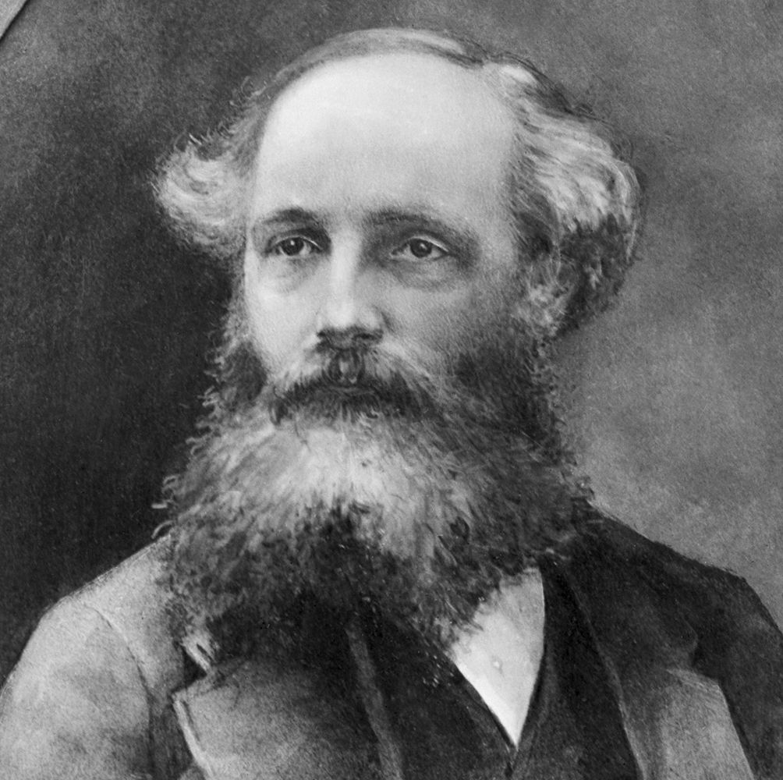
In the vast landscape of physics, few names stand as prominently as James Clerk Maxwell. This dedicated space delves into the rich tapestry of Maxwell's original works, casting light upon his pioneering theories, foundational equations, and the profound impact they've had on our understanding of the electromagnetic universe.
Here, we journey back to the roots of electromagnetic theory, exploring Maxwell's untouched formulations, the historical context in which they emerged, and the nuances often overshadowed by modern interpretations. From his groundbreaking theory on the electromagnetic field to his contributions to thermodynamics, this wiki serves as both a homage to Maxwell's genius and a reservoir of knowledge for enthusiasts, students, and scholars alike.
Whether you're a seasoned physicist, a student of history, or simply an inquisitive mind, this wiki offers a deep dive into the legacy of a man whose work continues to resonate through the corridors of science. Join us in rediscovering the original insights and inspirations of James Clerk Maxwell.

Contents
James Clerk Maxwell
Maxwell Original Equations
Iconic Figures
Maxwell's Variables Explored: Diving into Hypothetical Scenarios
Community Forumhttp://typeright.social/forum

